ỦY BAN NHÂN DÂN TP. HCM CỘNG HÒA XÃ HỘI CHỦ NGHĨA VIỆT NAM
TRƯỜNG CAO ĐẲNG LÝ TỰ TRỌNG TP.HCM Độc lập – Tự do – Hạnh phúc
________________ ____________

ĐỀ THI GIỮA HỌC PHẦN LÝ THUYẾT
HỌC PHẦN: NGHE 1 - HỌC KÌ: I - NH: 2017 - 2018
BẬC ĐÀO TẠO: TRUNG CẤP CHUYÊN NGHIỆP
LỚP: 17T4-NNA1, NNA2 NGÀY THI: …../……/2017
THỜI GIAN THI: 45 PHÚT

Task 1: You will hear a waiter taking people’s orders in a restaurant. Listen and write their orders. You will listen twice. (8 x 0.25=2p)
Menu 1: …………………………………………………………………………………………………………………………………………………….
Menu 2: …………………………………………………………………………………………………………………………………………………….
Menu 3: …………………………………………………………………………………………………………………………………………………….
Task 2: Listen. Write the names of the places people are going for shopping. You will listen twice. (4x 0.25= 1p)
1………………………………………….. 3……..…………………………………….
2………………………………………….. 4…………………….………………………
Task 3: Listen and fill in the blanks. You will listen twice. (16 x 0. 25 = 4p)
It’s not really the (1) …………………….. place to shop. (2) ………………………… are too (3)………………………….there nowadays. But the food’s (4)……………………….and quite cheap. It’s a (5)……………………………. place just to (6)……………………………… around in and look at the old (7)………………………… But there aren’t any interesting (8)……………………… or (9)……………………..I’m afraid.
It’s a very nice place to (10)…………………….. if you like being (11)…………………………. The scenery is beautiful. Take a bus (12)…………………………. around the (13)……………………… and sail around it if you have time. You can also go skiing. Unfortunately, the water is too cold there for (14)……………………… You (15)………………………… won’t like the (16)……………………… food. It’s very spicy.
Task 4: (6 x 0.25 = 1.5p) Listen and do the task below. You will listen twice.
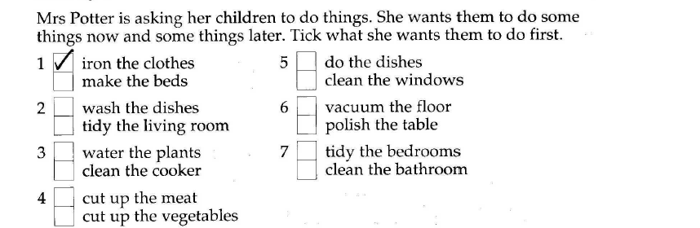
Task 5: People just arrived at the airport. They want different kinds of hotel accommodation. They each dial the hotels and receive a recorded message. Listen to the message and tick what you think the caller will do next. You will listen twice. (6 x 0.25 = 1.5p)
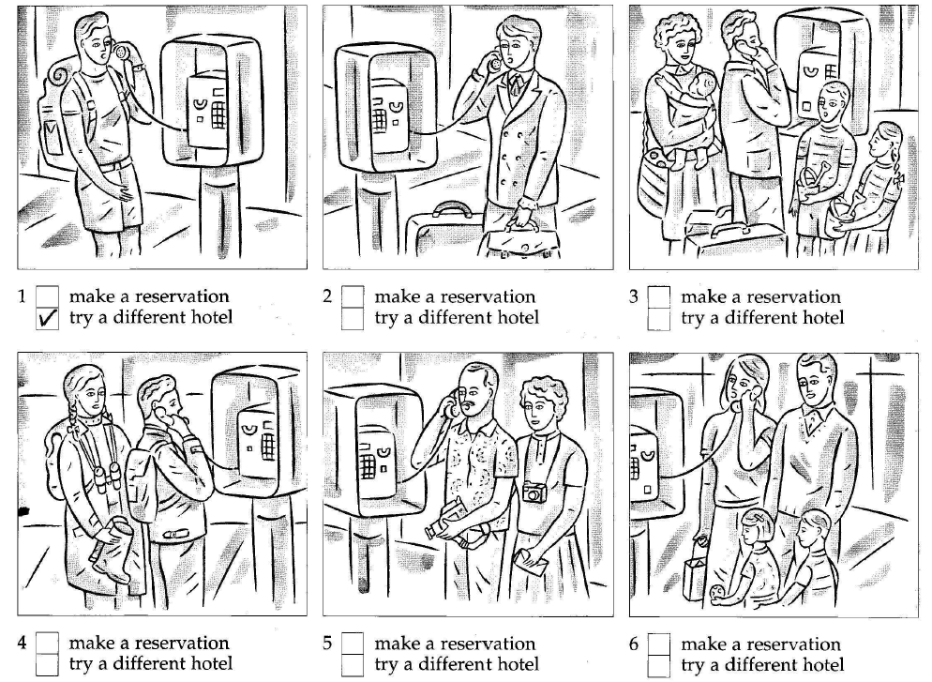

--The end --

